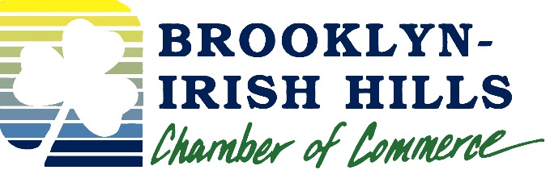
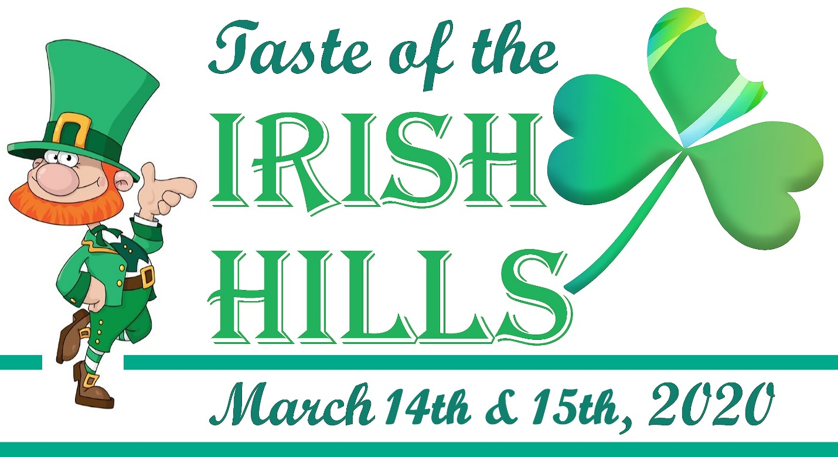

RE: Taste of the Irish Hills Press Release
March 14 & 15, 2020

Contacts: Cindy Hubbell, President/CEO Annette Roesch, Executive Assistant
Irish Hills Regional Chamber of Commerce Irish Hills Regional Chamber of Commerce
517-592-8907 or Cindy@IrishHills.com 517-592-8907 or Annette@IrishHills.com

Kick off St. Patrick’s Day with a TASTE of the Irish Hills

The Irish Hills Regional Chamber of Commerce presents the 10th annual Taste of the Irish Hills. This event takes place on Saturday March 14 and Sunday March 15, 2020. Tickets cost only $25 per person. Ticket holders will enjoy a self-guided tour of 22 Irish Hills restaurants, sampling some of their best cuisine over the two days.

This event has become a favorite for the Irish Hills. Not only do our residents look forward to it, it draws people from miles around,” comments Cindy Hubbell, President/CEO of the Irish Hills Regional Chamber of Commerce. “We are proud to hold this event for it’s 10th year. People really look forward to it, and go all out, dressing in their favorite Irish attire. Being we are the IRISH Hills, it makes sense to hold a region wide St. Patrick’s Day party.”

For a list of participating Taste of the Irish Hills businesses please visit IrishHills.com or the chamber’s Facebook page. Thank you to our sponsors; Visit Lenawee and TransPharm Preclinical Solutions.

Tickets are on sale at the chamber office (124 S. Main Street, Brooklyn) online at IrishHills.com and Woodstock Wine and Cheese. Tickets are also available at any participating restaurant the day of the event. Any questions, please call 517-592-8907.

